Lab2

## **Task-1: Caesar Cipher Encryption and Decryption Using Python**

### **1. Objective**

The objective of this lab is to implement the **Caesar Cipher**, one of the simplest and most well-known encryption techniques, using Python.  
 The program allows encrypting and decrypting text files based on a user-defined key.

### **2. Introduction**

The **Caesar Cipher** is a type of **substitution cipher** where each letter in the plaintext is shifted by a fixed number of positions in the alphabet.  
 For example, with a shift of 3, the letter **A** becomes **D**, **B** becomes **E**, and so on.  
 Decryption simply reverses this shift to restore the original text.

This project implements the cipher through a Python command-line interface (CLI) that reads data from a text file, performs encryption or decryption using a user-specified key, and saves the results to another file.

### **3. Implementation Details**

The Python program provides two main functionalities:

1. **Encrypt Text File**
   * Reads plaintext from a .txt file.
   * Encrypts it using a numeric key (1–25).
   * Saves the encrypted result in a new .txt file.
2. **Decrypt Text File**
   * Reads ciphertext from a .txt file.
   * Decrypts it using the same key.
   * Saves the decrypted result in another .txt file.

The user interacts with a simple text-based menu to choose between encryption, decryption, or exiting the program.

### **4. Working Principle**

Let key be the number of positions to shift:

* **Encryption Formula:**E(x) = (x+key)mod26
* **Decryption Formula:**D(x) = (x−key)mod26

Here, x represents the numerical position of a letter (A=0, B=1, ..., Z=25).

The program handles both uppercase and lowercase letters, while keeping spaces and punctuation unchanged.

### **5. Execution Steps**

#### **Step 1: Encryption Process**

1. Select **option 1** from the main menu.
2. Provide the **input file name** (e.g., plain.txt).
3. Provide the **output encrypted file name** (e.g., encrypted.txt).
4. Enter the **key value** between 1 and 25.
5. The program reads, encrypts, and saves the cipher text to the output file.

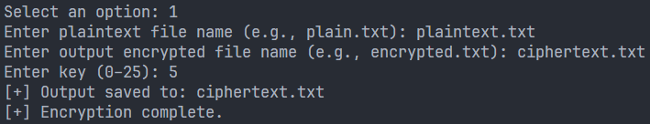

#### **Step 2: Decryption Process**

1. Select **option 2** from the main menu.
2. Provide the **input encrypted file name** (e.g., encrypted.txt).
3. Provide the **output decrypted file name** (e.g., decrypted.txt).
4. Enter the **same key** used for encryption.
5. The program reads, decrypts, and saves the original text to the output file.

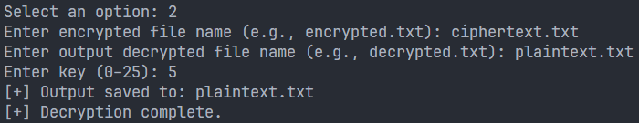

### **6. Sample Result**

**Plaintext (plain.txt):**

Attack at dawn

**Encrypted (encrypted.txt, key=5):**

Fyyfhp fy ifbs

**Decrypted (decrypted.txt):**

Attack at dawn!

## **Task-2: Substitution Cipher**

### **1. Objective**

The goal of this task was to understand and break a **substitution cipher** using Python. The cipher replaces each letter of the plaintext with another unique letter, forming a scrambled message that looks unreadable at first glance.

### **2. How It Works**

The program reads the encrypted text and tries to guess the original message using:

* **Letter frequency analysis** — comparing how often each letter appears to standard English frequencies.
* **Smart guessing** — automatically swapping letters to form real English words.
* **Refinement** — improving the mapping until the decrypted text looks meaningful.

### **3. Process**

1. The cipher text is analyzed for frequency patterns.
2. The program builds an initial guess of letter mappings (e.g., most frequent → 'E').
3. It tests and swaps letters using a dictionary of English words.
4. The final result is printed with a likely plaintext and key mapping.

### 

### **4. Results**

* The algorithm successfully decrypted most of the given cipher text.
* Longer texts were easier to solve since they gave better frequency data.
* Short or unusual texts were trickier and needed a few manual swaps.

Lab3

# **Lab 3 Report: Symmetric Encryption & Hashing**

This report details the findings from Lab 3, covering experiments with symmetric encryption modes (AES), padding, and hash functions (MD5, SHA) using the openssl and ghex tools.

### **Task 1: AES Encryption (Different Modes)**

* **Objective:** To encrypt and decrypt a single file using three different AES modes (CBC, CFB, OFB) to confirm their functionality.
* **Commands:**  
  # CBC Mode Example  
  openssl enc -aes-128-cbc -e -in plain.txt -out cipher-cbc.bin -K <key> -iv <iv>  
  openssl enc -aes-128-cbc -d -in cipher-cbc.bin -out decrypted-cbc.txt -K <key> -iv <iv>
* **Key Findings:** All three modes (CBC, CFB, OFB) successfully encrypted and decrypted the plain.txt file. The resulting ciphertext files (cipher-cbc.bin, cipher-cfb.bin, cipher-ofb.bin) were all different from one another, demonstrating the different cryptographic processes of each mode.

### **Task 2: ECB vs. CBC (Image Encryption)**

* **Objective:** To visually compare the security of ECB (Electronic Code Book) and CBC (Cipher Block Chaining) modes by encrypting a .bmp image.
* **Commands:**  
  # ECB Mode (Insecure)  
  openssl enc -aes-128-ecb -e -in pic_original.bmp -out pic_ecb.bmp -K <key>  
  # CBC Mode (Secure)  
  openssl enc -aes-128-cbc -e -in pic_original.bmp -out pic_cbc.bmp -K <key> -iv <iv>
* **Key Findings:**
  + **ECB mode is insecure for structured data.** Because ECB encrypts identical plaintext blocks into identical ciphertext blocks, the pattern of the original image was still visible.
  + **CBC mode is secure.** It produced random, unrecognizable static (noise) because each block's encryption is chained to the previous one, successfully obscuring all original data patterns.

### **Task 3: Corrupted Ciphertext (Error Propagation)**

* **Objective:** To analyze how a single-bit error in a ciphertext file (created using ghex) affects the decrypted plaintext across four different modes.
* **Key Findings:** The effect of a 1-bit error varies significantly by mode:

|  |  |
| --- | --- |
| **Mode** | **Error Propagation Result** |
| **ECB** | Corrupts the **entire** 16-byte block of plaintext where the error occurred. |
| **CBC** | Corrupts the **entire** 16-byte block (like ECB) AND causes a **single-bit flip** in the *next* block. |
| **CFB** | Corrupts a **single bit** at the error's position, and then garbles data for the *length of the next block* (16 bytes). |
| **OFB** | Corrupts **only the single bit** at the exact position of the error. The error does not propagate. |

### **Task 4: Padding**

* **Objective:** To determine which encryption modes require padding when the input size (20 bytes) is not a multiple of the block size (16 bytes).
* **Key Findings:**
  + **ECB & CBC (Block Cipher Modes):** **Require padding.** The 20-byte file was padded to 32 bytes (the next multiple of 16).
  + **CFB & OFB (Stream Cipher Modes):** **Do not require padding.** The 20-byte input file produced a 20-byte output file. This is because these modes operate as stream ciphers, encrypting byte-by-byte rather than block-by-block.

### **Task 5: Generating Message Digest (Hashing)**

* **Objective:** To generate hash digests for a single file using three different algorithms (MD5, SHA-1, SHA-256).
* **Commands:**  
  openssl dgst -md5 plain-task5.txt  
  openssl dgst -sha1 plain-task5.txt  
  openssl dgst -sha256 plain-task5.txt  
  
* **Key Findings:** All three algorithms produced completely different hash values for the *same* file. The output length is fixed and distinct for each algorithm (MD5: 128-bit, SHA-1: 160-bit, SHA-256: 256-bit).

### **Task 6: Keyed Hash (HMAC)**

* **Objective:** To generate HMACs (Keyed Hashes) and investigate whether the key size must be fixed.
* **Commands:**  
  # Short Key  
  openssl dgst -sha256 -hmac "key-1" plain-task6.txt  
  # Long Key  
  openssl dgst -sha256 -hmac "this-is-a-very-long-and-complex-key" plain-task6.txt
* **Generated Short key HMACs**



* **Generated Long Key HMACs**



* **Key Findings:** **HMAC does not require a fixed-size key.** The HMAC standard internally handles variable-length keys. If a key is too long, it is hashed down; if too short, it is padded. The *output* length is determined by the hash function (e.g., SHA-256), not the key length.

### **Task 7: The Avalanche Effect**

* **Objective:** To observe the **Avalanche Effect** by flipping a single bit in an input file (using ghex) and comparing the "before" ($H_1$) and "after" ($H_2$) hashes.
* **Key Findings:** The **Avalanche Effect** was clearly observed. Flipping a *single bit* in the input file (e.g., changing 'T' to 'U') caused a massive, ~50% change in the output bits for both MD5 and SHA-256. $H_1$ and $H_2$ appeared completely unrelated, confirming this core property of secure hash functions.

**MD5 Algorithm Difference:**

**Unmodified**



**Modified**



**SHA256 Algorithm Difference:**

**Unmodified**



**Modified**



**Unmodified File**

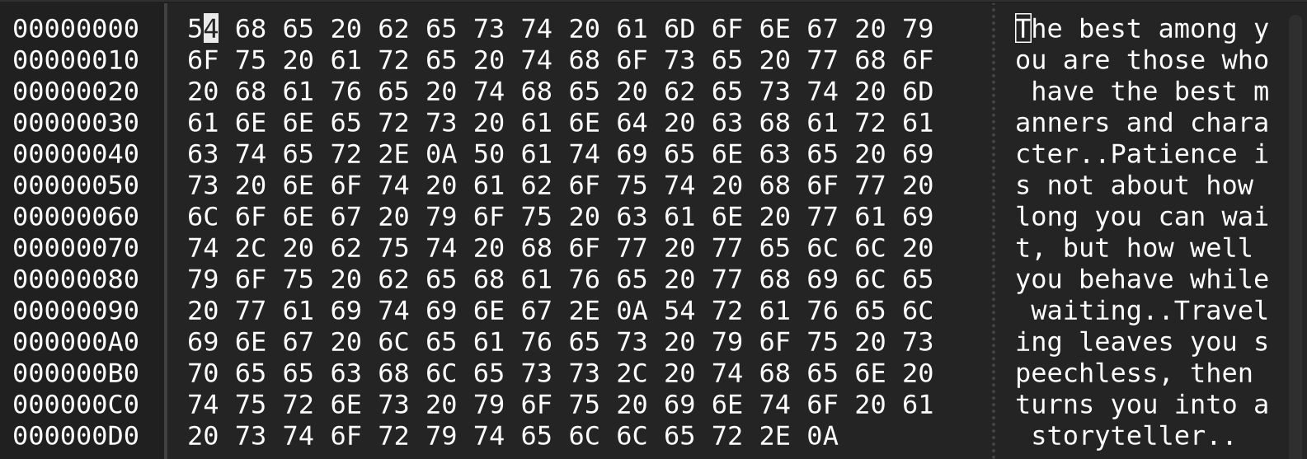

**Modified File**

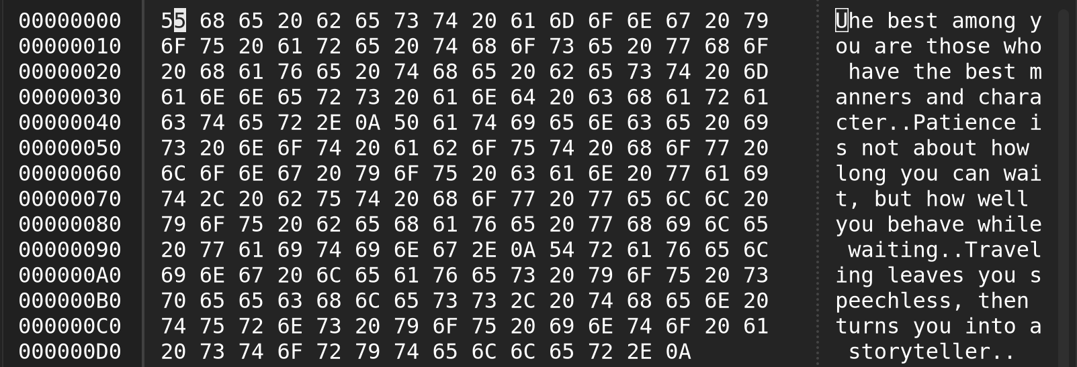

Lab4

# **Lab Report: Programming Symmetric & Asymmetric Cryptography**

## **1. Objective**

The objective of this lab is to **implement symmetric and asymmetric cryptography** using a single command-line program that simulates the behavior of the OpenSSL tool.

Specifically, the program performs:

* AES Encryption & Decryption (ECB & CFB modes, 128/256-bit keys)
* RSA Encryption & Decryption
* RSA Digital Signature Generation & Verification
* SHA-256 Hashing of files
* Timing Measurement for AES and RSA operations

## **2. Tools and Environment**

|  |  |
| --- | --- |
| **Tool** | **Description** |
| **Operating System** | Windows 11 |
| **Programming Language** | Python 3 |
| **Cryptography Backend** | System OpenSSL via subprocess |
| **Required Files** | cryptic_cli_tool.py, message.txt, signature.txt |
| **Generated Files** | RSA keys (.pem), AES keys (.key), encrypted/decrypted files, signatures, IVs |

## **3. Program Overview**

The Python program cryptic_cli_tool.py acts as a **menu-driven CLI wrapper** around OpenSSL commands.  
 It automatically generates keys on first run and allows the user to choose operations through numeric options.

**Main Menu:**

1) Generate keys (RSA & AES) [one time]

2) AES encrypt file

3) AES decrypt file

4) RSA encrypt file

5) RSA decrypt file

6) RSA sign file (SHA-256)

7) RSA verify signature

8) SHA-256 hash file

9) Timing experiment (RSA key sizes)

10) Timing experiment (AES modes/key sizes)

0) Exit

## 

## 

## 

## 

## 

## 

## 

## **4. Implementation Details**

### **Option 1 – Generate Keys**

This option creates:

* **RSA 2048-bit key pair**:  
   rsa_private.pem, rsa_public.pem
* **AES keys**:  
   aes_key_128.key (16 bytes), aes_key_256.key (32 bytes)

Keys are stored locally for later reuse.

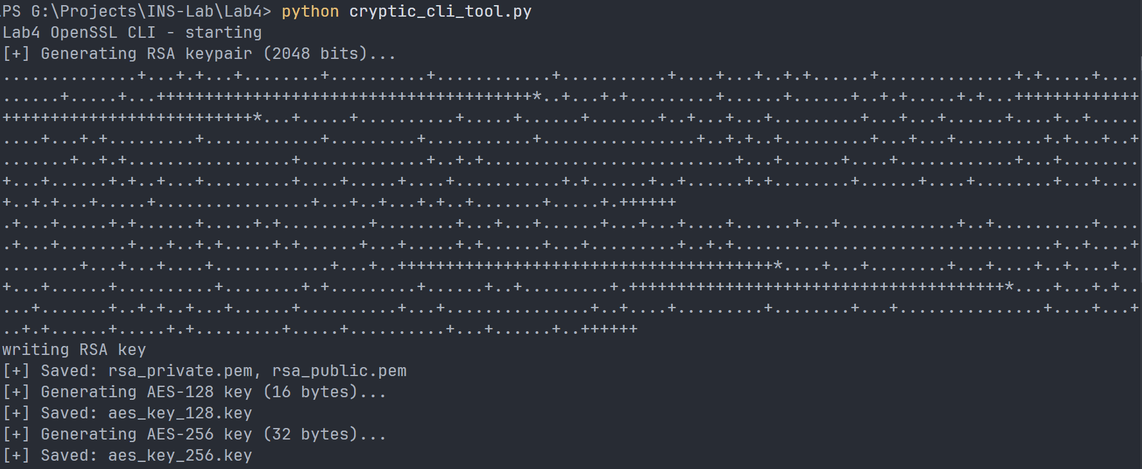

### **Option 2 – AES Encryption**

Encrypts a plaintext file using OpenSSL’s AES algorithm.  
User selects **key length** (128 or 256 bits) and **mode** (ECB or CFB).

* The resulting ciphertext is saved in .enc file.
* In CFB mode, an IV is also generated (.enc.iv).
* Execution time is displayed.

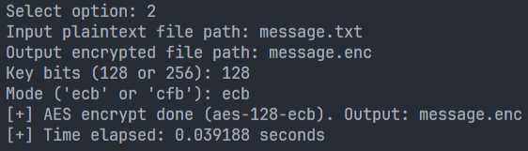

**Message.enc file**

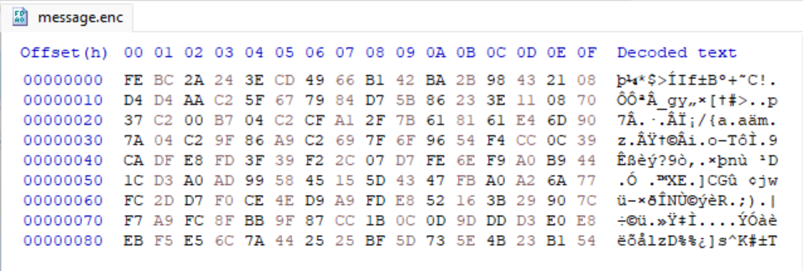

### **Option 3 – AES Decryption**

Decrypts a previously encrypted file using the same key and mode.  
 Displays the original plaintext on screen for verification.

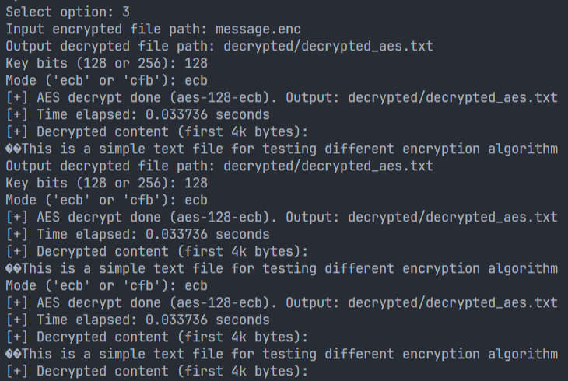

### **Option 4 – RSA Encryption**

Encrypts a small text file using the RSA public key (rsa_public.pem).  
 RSA is slow and meant for short messages or key exchange only.  
 The output binary ciphertext is saved as .enc.

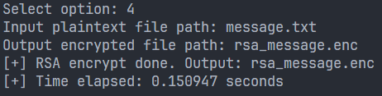

### **Option 5 – RSA Decryption**

Decrypts the RSA-encrypted file using the private key (rsa_private.pem).  
 Shows the recovered plaintext in console to prove successful decryption.

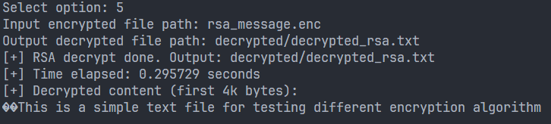

### **Option 6 – RSA Digital Signature Generation**

Generates a **SHA-256 hash** of the input file and signs it using the RSA private key.  
 The signature is stored in a binary .sig file.

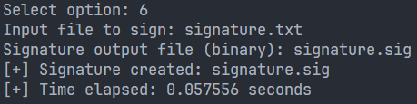

### **Option 7 – RSA Signature Verification**

Verifies the signature using the RSA public key and the original file.  
 If the file is unaltered, OpenSSL prints **“Verified OK”**.

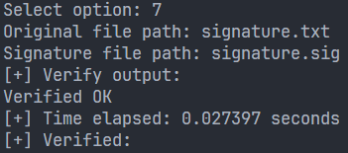

### **Option 8 – SHA-256 Hashing**

Computes a SHA-256 digest of any file and prints it to the console.  
 This is commonly used for integrity checking and file fingerprinting.



### **Option 9 – RSA Timing Experiment**

Automatically generates temporary RSA keys of different sizes (512 → 4096 bits) and measures the encryption/decryption times.  
 Results are printed as a table.  
 You can use these values to plot RSA key size vs execution time.

**Message.txt**(small size)  
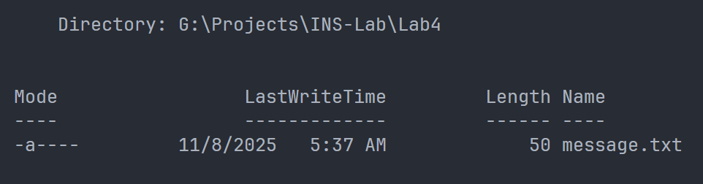

**RSA Results**

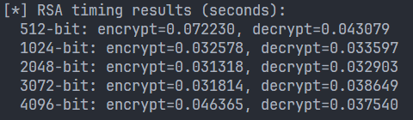

### **Option 10 – AES Timing Experiment**

Measures the execution time of AES encryption and decryption for:

* AES-128-ECB **: 0.283255 seconds** **| 0.025837 seconds**
* AES-128-CFB **: 0.026455 seconds | 0.024036 seconds**
* AES-256-ECB **: 0.026533 seconds | 0.026006 seconds**
* AES-256-CFB **: 0.025252 seconds | 0.024015 seconds**

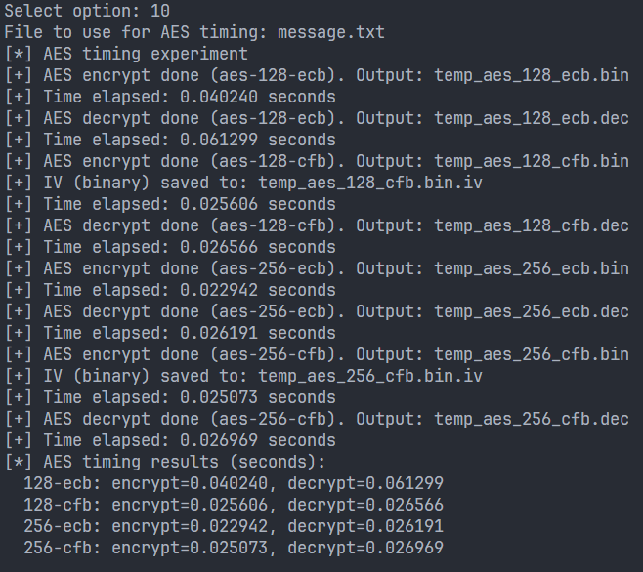

## **5. Conclusion**

In this lab, we successfully implemented and tested various cryptographic operations using OpenSSL through a Python interface.  
 The program demonstrated the mechanics of:

* Key generation and management
* Symmetric vs asymmetric encryption
* Digital signatures and integrity checking
* Performance measurement of cryptographic algorithms

## **6. References**

1. OpenSSL Manual Pages –<https://www.openssl.org/docs/manmaster/>
2. Python subprocess Module Documentation –<https://docs.python.org/3/library/subprocess.html>
3. Lab Manual 4 – CSE-478 (Department of Computer Science & Engineering)

Lab5

# **Web Lab Report – Lab 5: Securing Apache Web Server with SSL/TLS**

## **🔹 Objective**

The purpose of this lab is to:

* Learn how to create and use **self-signed SSL/TLS certificates** using OpenSSL.
* Configure **Apache Web Server** to serve websites securely over HTTPS.
* Understand the basic concept of **encryption and authentication** on the web.

## **🔹 Overview (in Simple Terms)**

Normally, when we use a website with http://, the data travels in plain text.  
 Anyone in the middle can see it — which is **not secure**.

Using **HTTPS (SSL/TLS)**:

* Encrypts the communication between browser and server.
* Prevents hackers from reading or modifying the data.
* Uses **certificates** to prove the website’s identity.

In real life, these certificates come from trusted companies called **Certificate Authorities (CAs)**.  
 In this lab, we created our **own CA** and used it to issue certificates for our local Apache sites.

## 

## **🔹 Tools Used**

* **Ubuntu Linux**
* **Apache2 Web Server**
* **OpenSSL**
* **Firefox**
* **Terminal & Text Editor (nano)**

## **🔹 Step-by-Step Procedure**

### **Step 1: Prepare the Workspace**

We first created a folder to store all our certificate files:

mkdir -p ~/lab5-ca && cd ~/lab5-ca

Then copied the OpenSSL config file:

cp /etc/ssl/openssl.cnf ./openssl.cnf

### **Step 2: Create a Root Certificate Authority (CA)**

A CA is like an ID authority that signs certificates for others.  
 We created folders for our CA database:

mkdir -p demoCA/{certs,crl,newcerts,private}

touch demoCA/index.txt

echo 1000 > demoCA/serial

Then we generated a **self-signed CA certificate**:

openssl req -new -x509 -days 3650 -extensions v3_ca \

-keyout demoCA/private/ca.key -out demoCA/ca.crt \

-config ./openssl.cnf

This created two files:

* ca.key → private key (keep it secret)
* ca.crt → your CA certificate

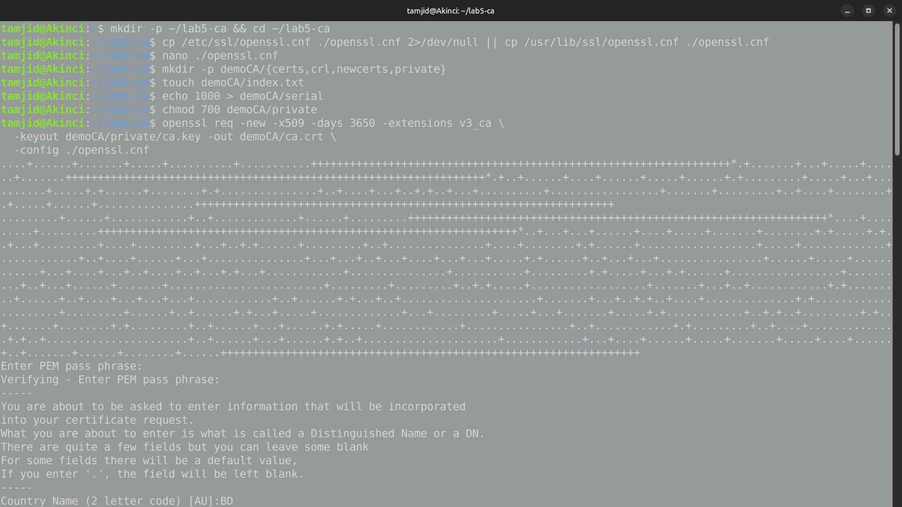

### **Step 3: Create a Key and Certificate Request for the Server**

Next, we generated a private key for our website:

openssl genrsa -des3 -out server.key 2048

Then created a **CSR (Certificate Signing Request)**:

openssl req -new -key server.key -out server.csr -config ./openssl.cnf

When asked for “Common Name,” we entered:

example.com

This request will later be signed by our CA.

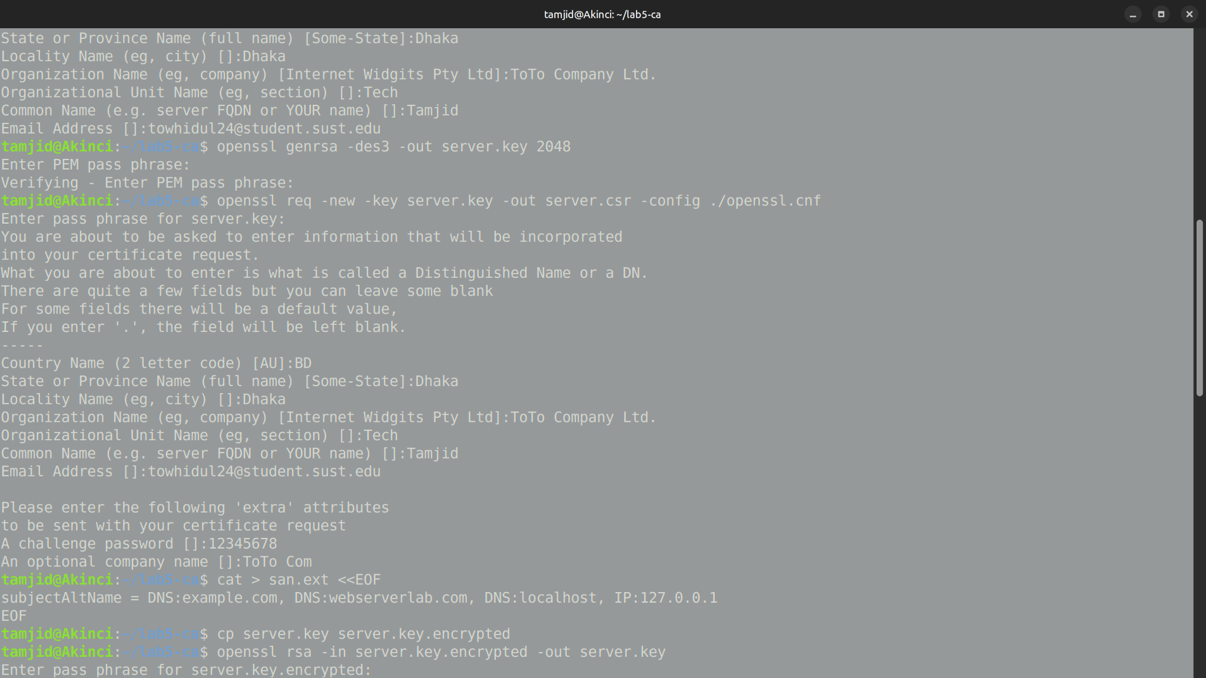

### **Step 4: Add SAN (Subject Alternative Names)**

To make the certificate valid for multiple domains (like example.com, localhost),  
 we created a file named san.ext:

subjectAltName = DNS:example.com, DNS:webserverlab.com, DNS:localhost, IP:127.0.0.1

This ensures browsers won’t complain about mismatched hostnames.

### **Step 5: Sign the Certificate with Our CA**

We used our CA to sign the CSR and generate the actual certificate:

openssl x509 -req -in server.csr -CA demoCA/ca.crt -CAkey demoCA/private/ca.key \

-CAcreateserial -out server.crt -days 825 -sha256 -extfile san.ext

Now we have:

* server.crt → signed certificate
* server.key → server’s private key

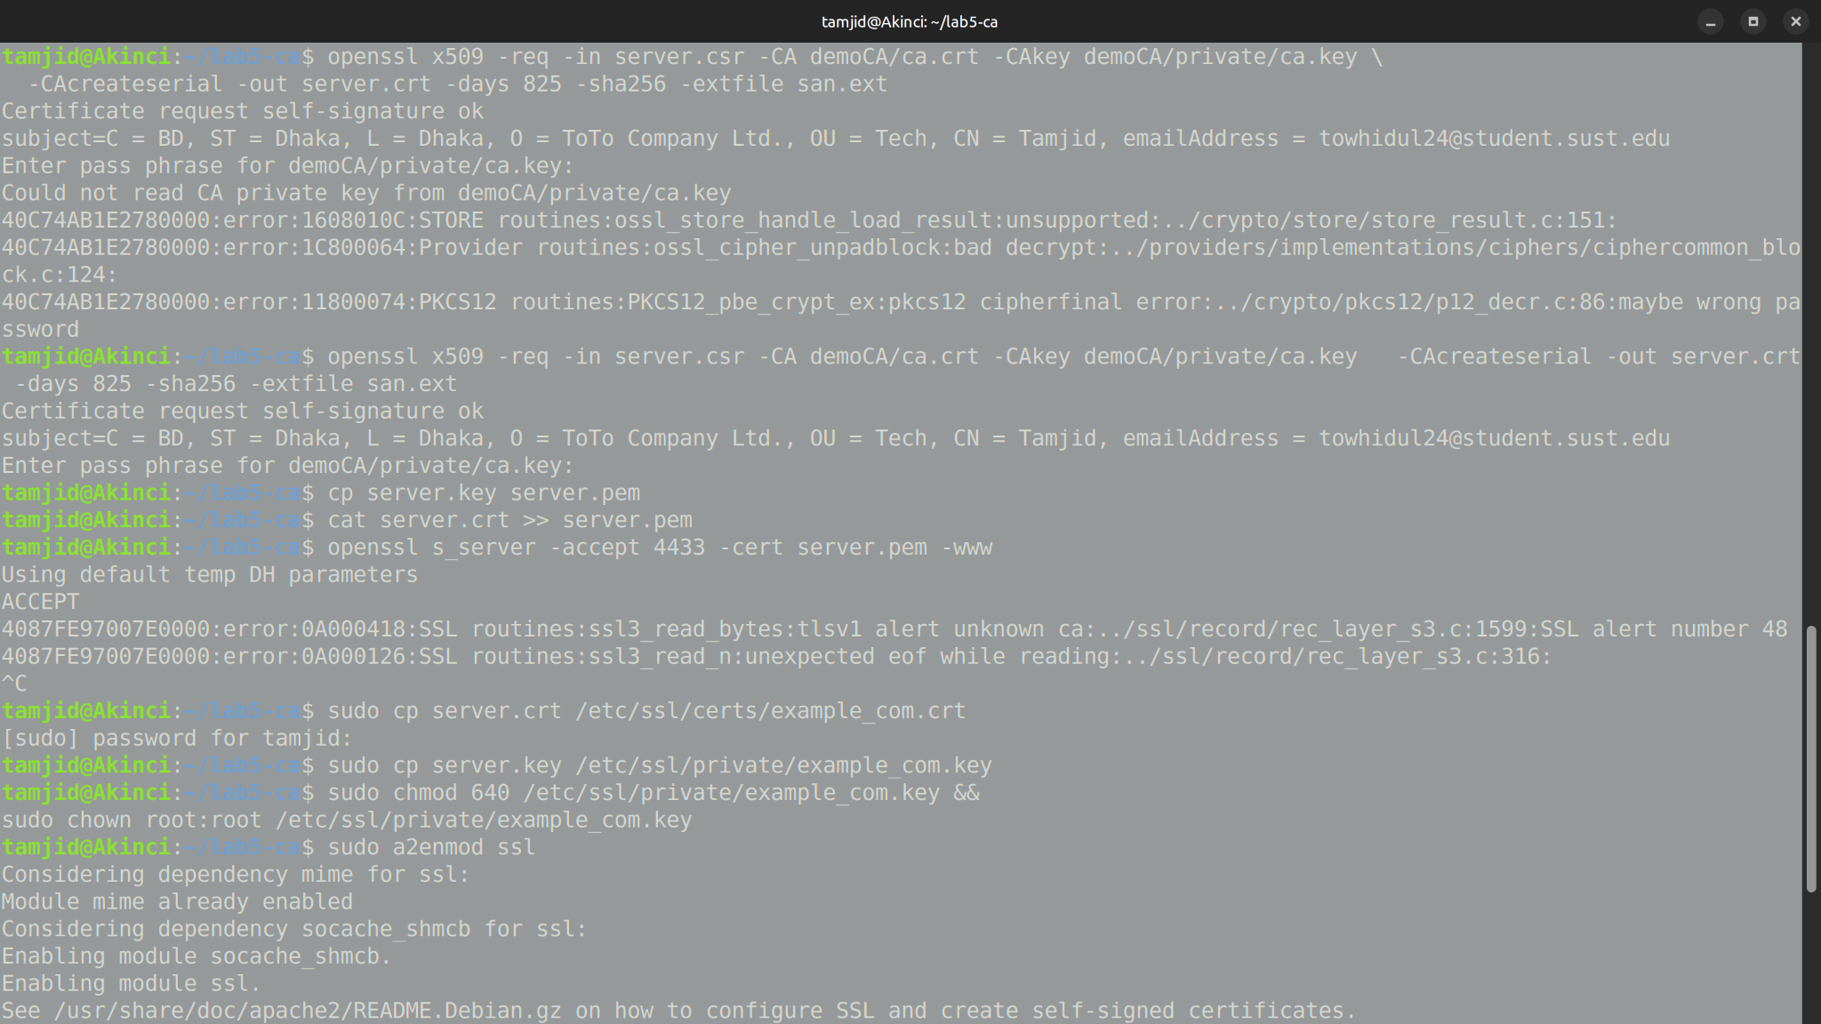

### **Step 6: Test HTTPS with OpenSSL**

Before using Apache, we tested our certificate with OpenSSL’s built-in web server:

cp server.key server.pem

cat server.crt >> server.pem

openssl s_server -accept 4433 -cert server.pem -www

Then opened a browser and went to:

https://localhost:4433

At first, it showed a warning because the browser didn’t yet trust our CA.

### **Step 7: Import Root CA into Browser**

We added our CA to Firefox so it trusts our certificates:

**In Firefox:**

1. Go to **Settings → Privacy & Security → Certificates → View Certificates**

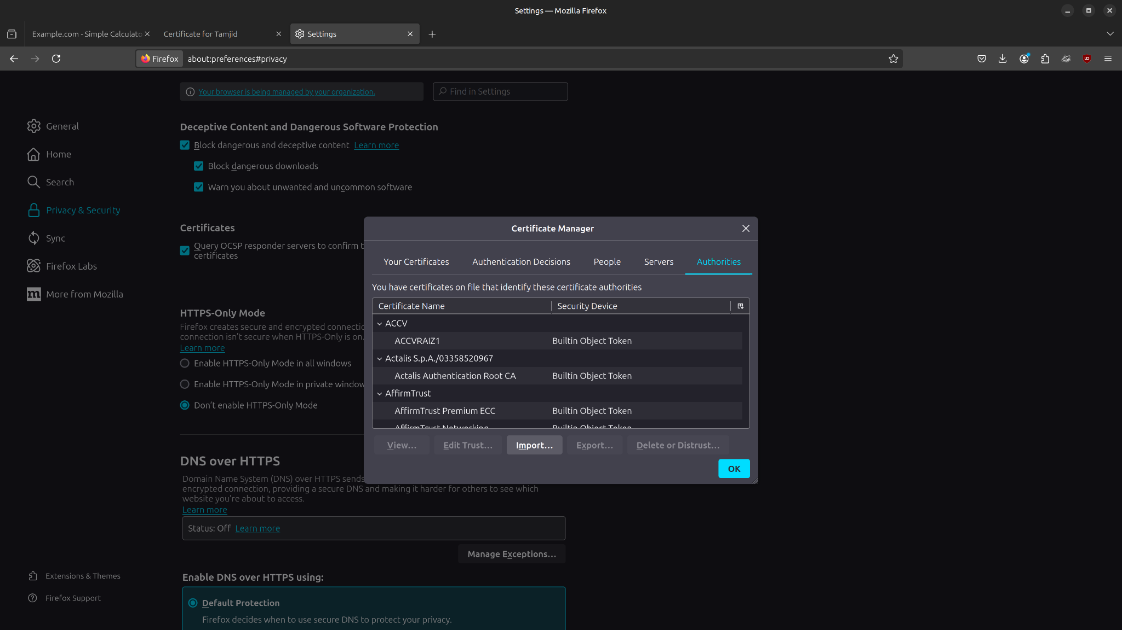

1. Click **Import…** and select demoCA/ca.crt

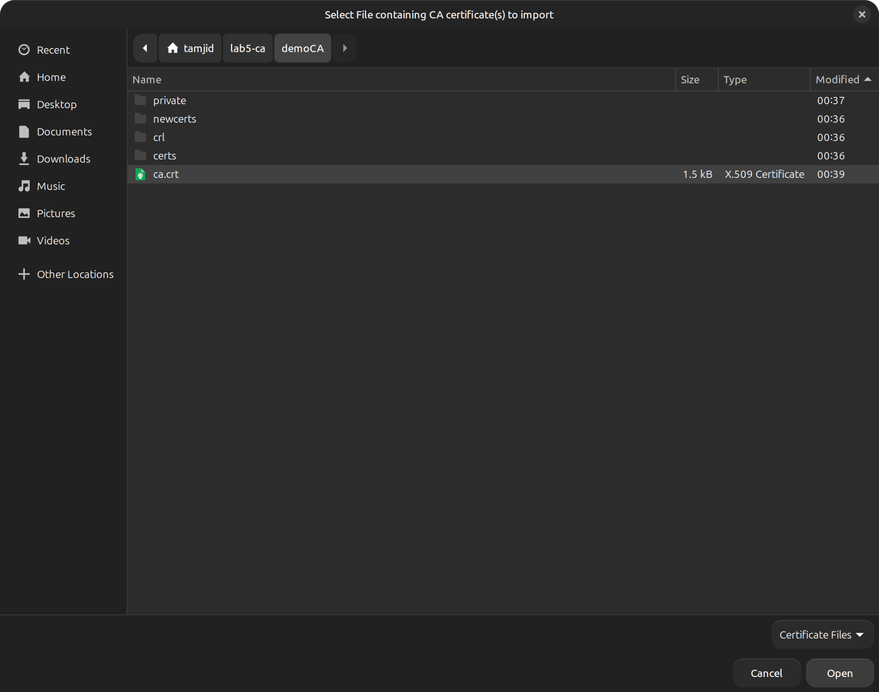

1. Check **Trust this CA to identify websites**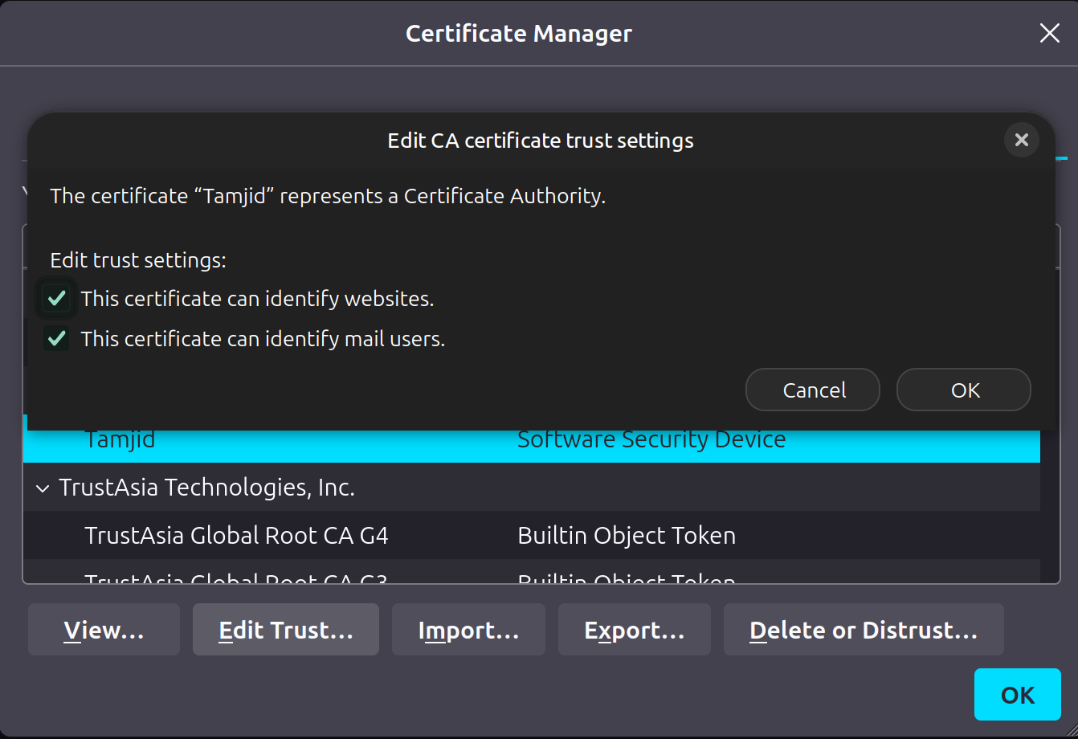

Certificate details in Firefox browser

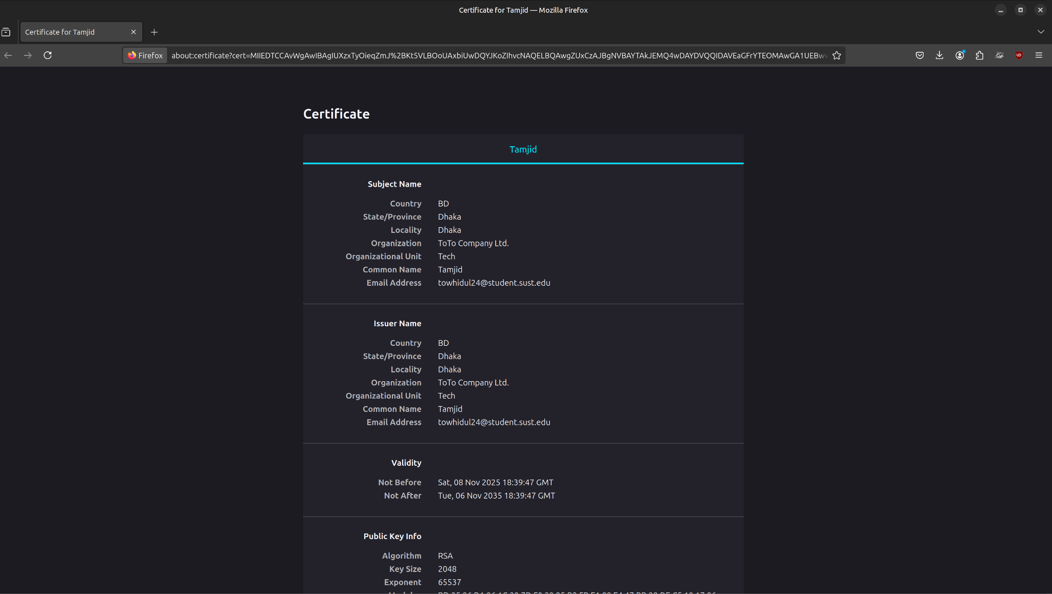

After that, refreshing the site showed a **padlock icon** — meaning HTTPS is working and trusted.

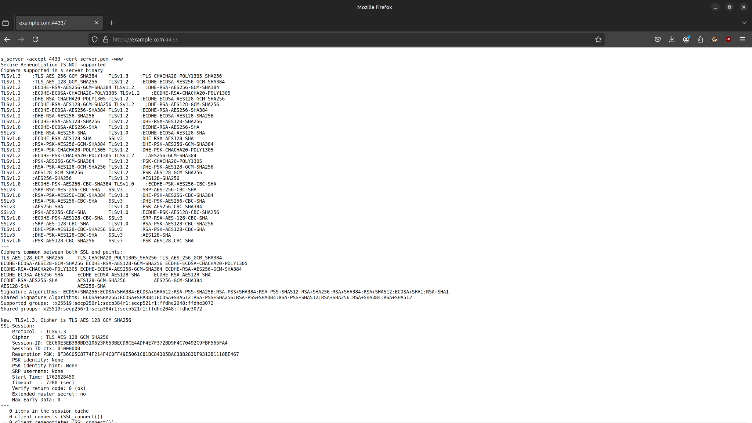

### **Step 8: Configure Apache for HTTPS**

We copied the certificate and key to system folders:

sudo cp server.crt /etc/ssl/certs/example_com.crt

sudo cp server.key /etc/ssl/private/example_com.key

Enabled SSL module:

sudo a2enmod ssl

sudo systemctl restart apache2

Then edited the Apache virtual host file:

sudo nano /etc/apache2/sites-available/example.com.conf

Added this block:

<IfModule mod_ssl.c>

<VirtualHost *:443>

ServerAdmin admin@example.com

ServerName example.com

DocumentRoot /var/www/example.com/html

SSLEngine on

SSLCertificateFile /etc/ssl/certs/example_com.crt

SSLCertificateKeyFile /etc/ssl/private/example_com.key

ErrorLog ${APACHE_LOG_DIR}/example_ssl_error.log

CustomLog ${APACHE_LOG_DIR}/example_ssl_access.log combined

</VirtualHost>

</IfModule>

Tested configuration:

sudo apache2ctl configtest

sudo systemctl restart apache2

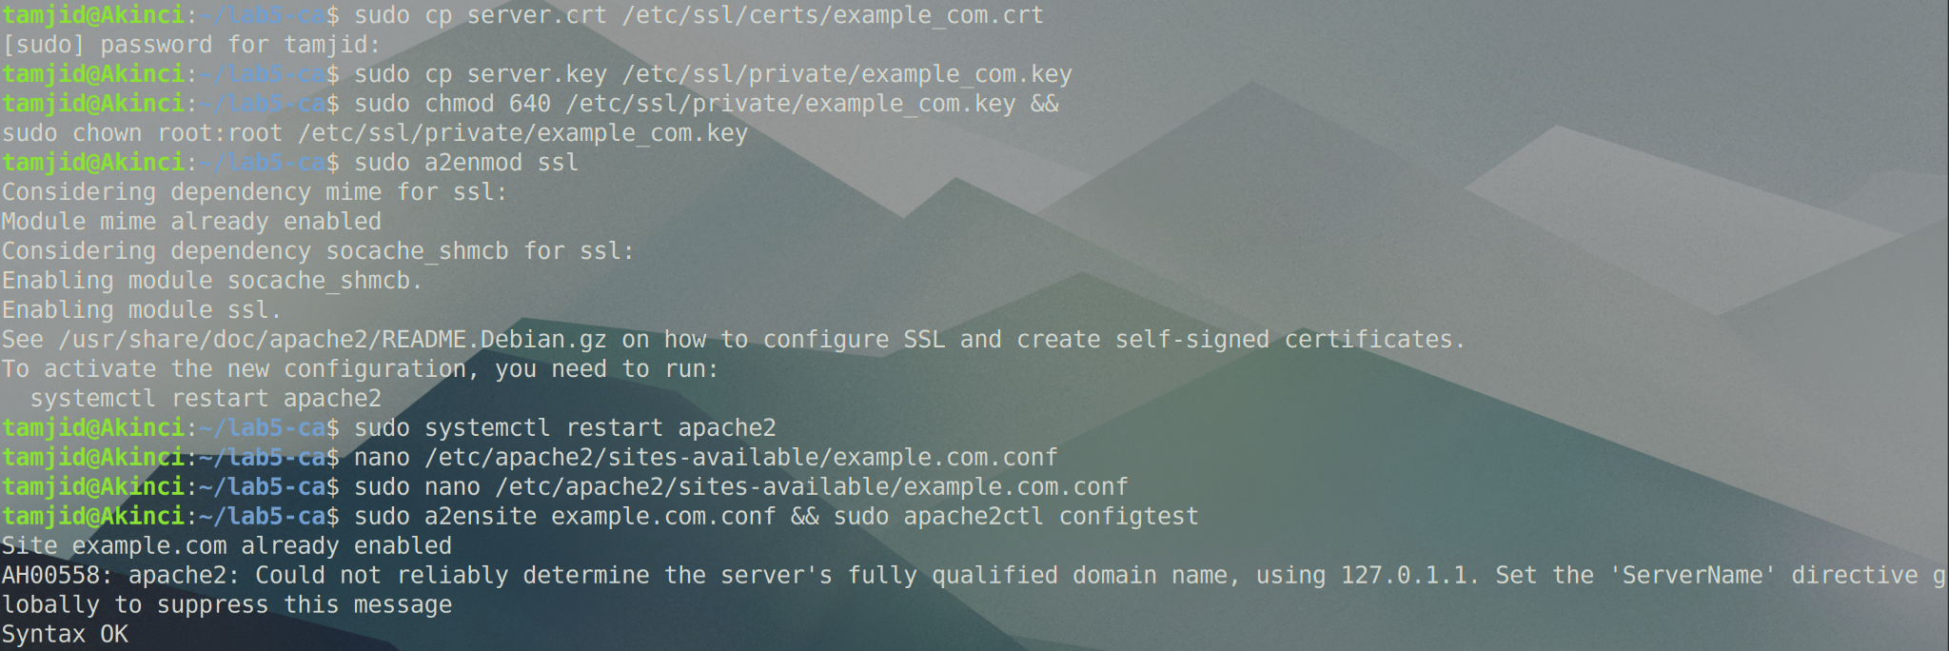

### **Step 9: Verify HTTPS Website**

Finally, we opened:

https://example.com

and saw the page load successfully with a **secure padlock** in the address bar.  
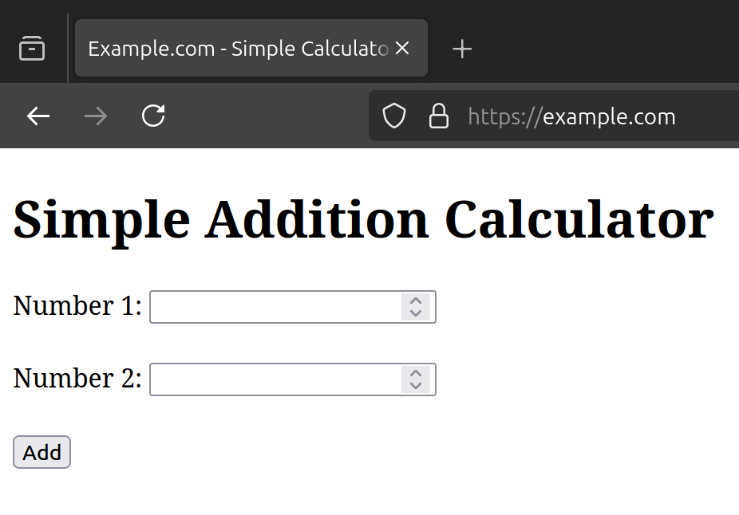

## **🔹 Results**

|  |  |  |
| --- | --- | --- |
| **Task** | **Description** | **Status** |
| 1 | Created self-signed CA | ✅ Done |
| 2 | Generated server certificate | ✅ Done |
| 3 | Tested HTTPS using OpenSSL | ✅ Done |
| 4 | Imported CA into browser | ✅ Done |
| 5 | Configured Apache for HTTPS | ✅ Done |

## **🔹 Observations**

* HTTPS encrypts communication, making it safer than HTTP.
* Self-signed CAs can be used for learning and local development.
* Once the CA is imported, browsers treat our certificates as trusted.
* Apache needs SSL enabled (mod_ssl) to handle HTTPS requests.
* The padlock icon proves encryption and certificate trust.

Web Lab 01

# **🧾 Web Lab Report — Apache Web Server**

## **🔹 Objective**

To install and configure Apache Web Server on Ubuntu, create and manage multiple virtual hosts, and understand how hostname resolution works using the /etc/hosts file.

## **🔹 Checkpoint-1: Apache Installation and Default Page**

### **Step 1.1 – Install Apache**

sudo apt update

sudo apt install apache2 -y

### **Step 1.2 – Allow Apache Through Firewall**

sudo ufw allow 'Apache'

sudo ufw status

### **Step 1.3 – Verify Apache Service**

sudo systemctl status apache2

Confirm it shows **active (running)**.

### **Step 1.4 – Add Local Domain**

Edit /etc/hosts and add:

127.0.0.1 localhost webserverlab.com

### **Step 1.5 – Test in Browser**

Visit:

http://webserverlab.com

You should see the **Apache2 Ubuntu Default Page**.

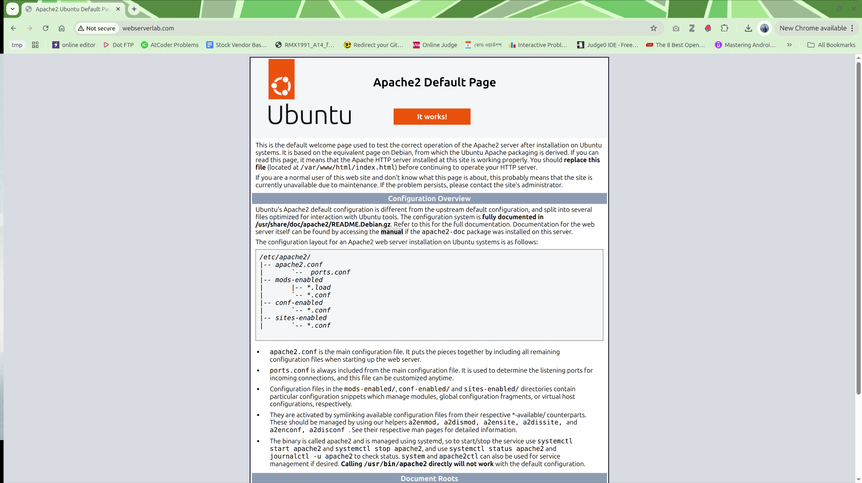

## **🔹 Checkpoint-2: Create and Configure First Virtual Host (example.com)**

### **Step 2.1 – Create Directory Structure**

sudo mkdir -p /var/www/example.com/html

sudo chown -R $USER:$USER /var/www/example.com/html

sudo chmod -R 755 /var/www/example.com

### **Step 2.2 – Create Website Content**

nano /var/www/example.com/html/index.html

<html>

<head><title>Welcome to Example.com!</title></head>

<body><h1>Success! example.com virtual host is working!</h1></body>

</html>

### **Step 2.3 – Create Virtual Host Config**

sudo nano /etc/apache2/sites-available/example.com.conf

<VirtualHost *:80>

ServerAdmin admin@example.com

ServerName example.com

ServerAlias www.example.com

DocumentRoot /var/www/example.com/html

ErrorLog ${APACHE_LOG_DIR}/example_error.log

CustomLog ${APACHE_LOG_DIR}/example_access.log combined

</VirtualHost>

### **Step 2.4 – Enable Site and Disable Default**

sudo a2ensite example.com.conf

sudo a2dissite 000-default.conf

sudo systemctl restart apache2

### **Step 2.5 – Update /etc/hosts**

127.0.0.1 localhost webserverlab.com example.com

### **Step 2.6 – Test Site**

Visit:

http://example.com

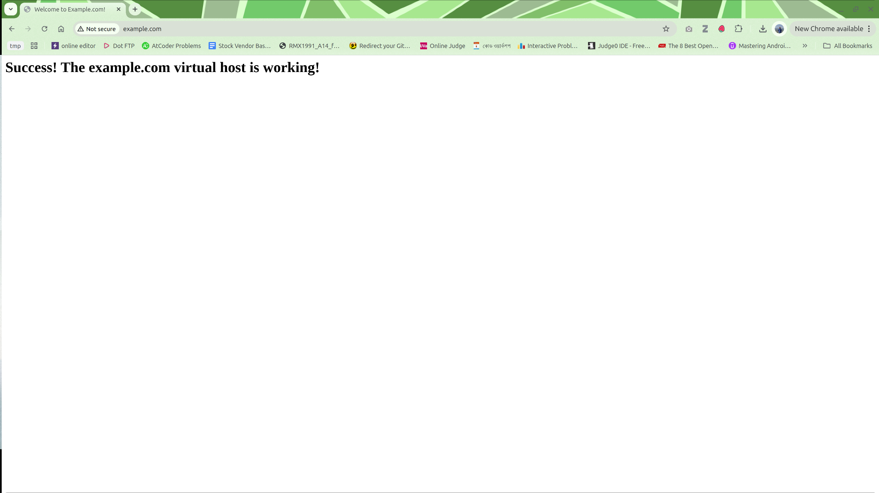

## **🔹 Checkpoint-3: Observing Default Host Behavior**

Now visit:

http://webserverlab.com

http://127.0.0.1

Both URLs will load the same content as example.com.

🧠 **Reason:** When 000-default.conf is disabled, Apache uses the **first active virtual host** as the default for any unmatched request.

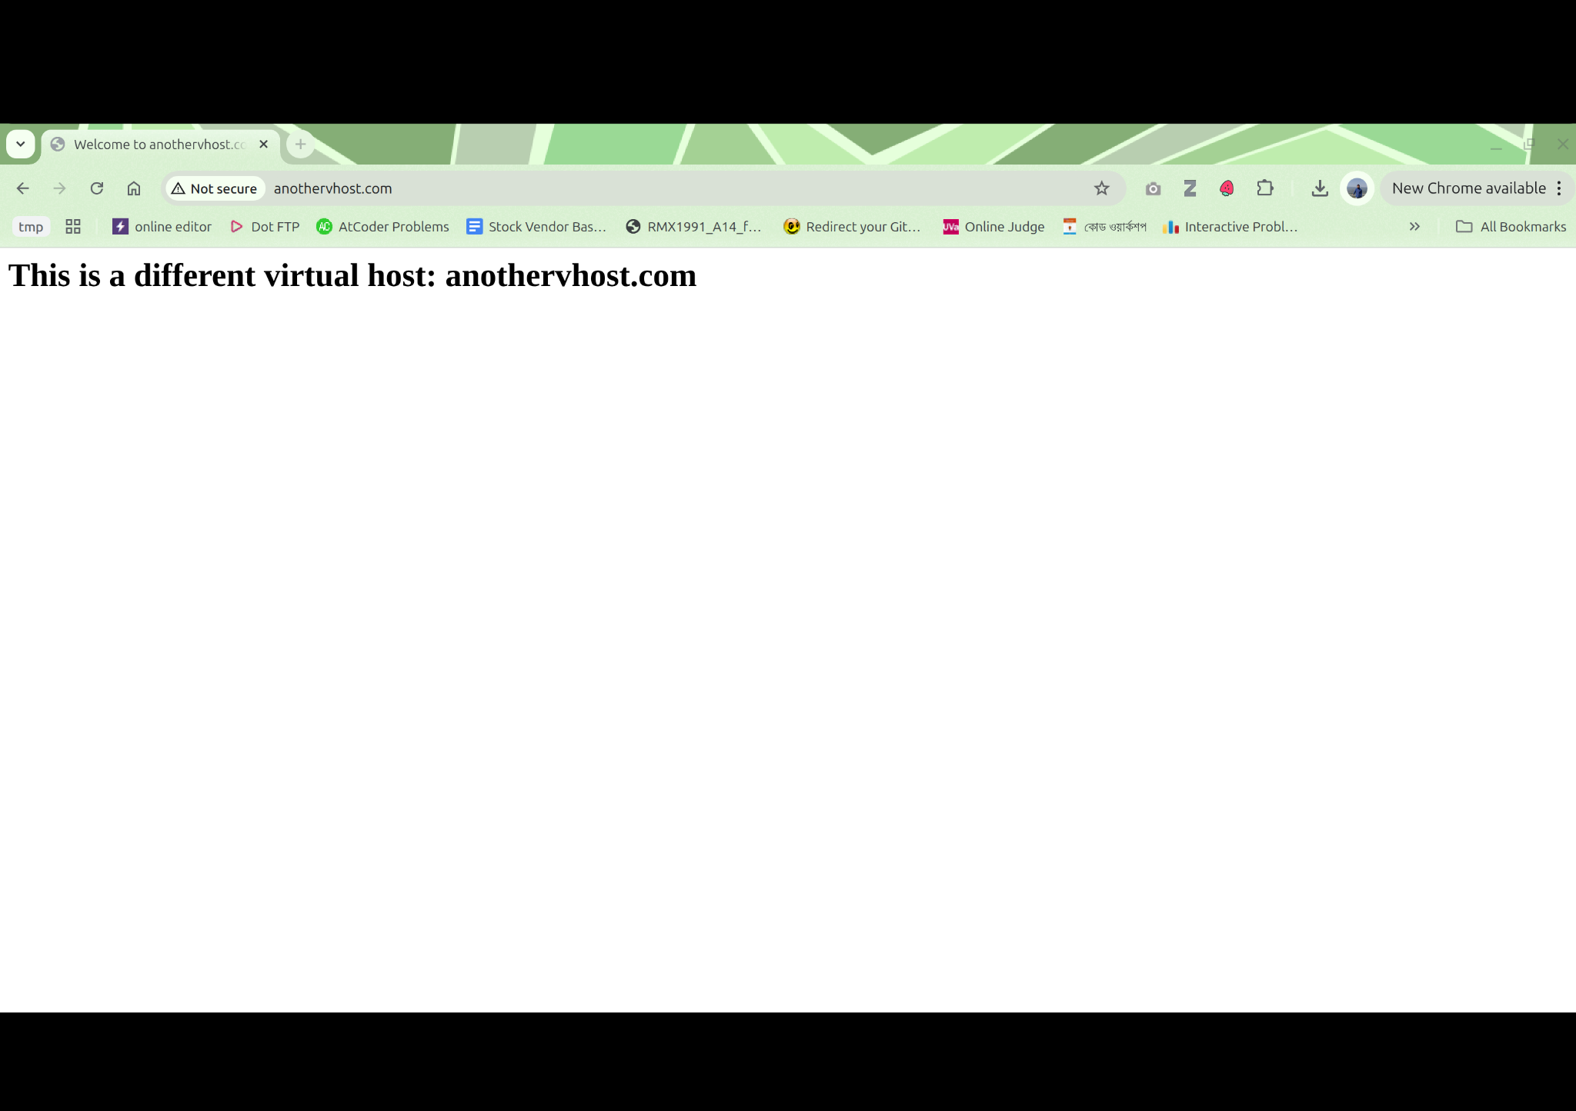

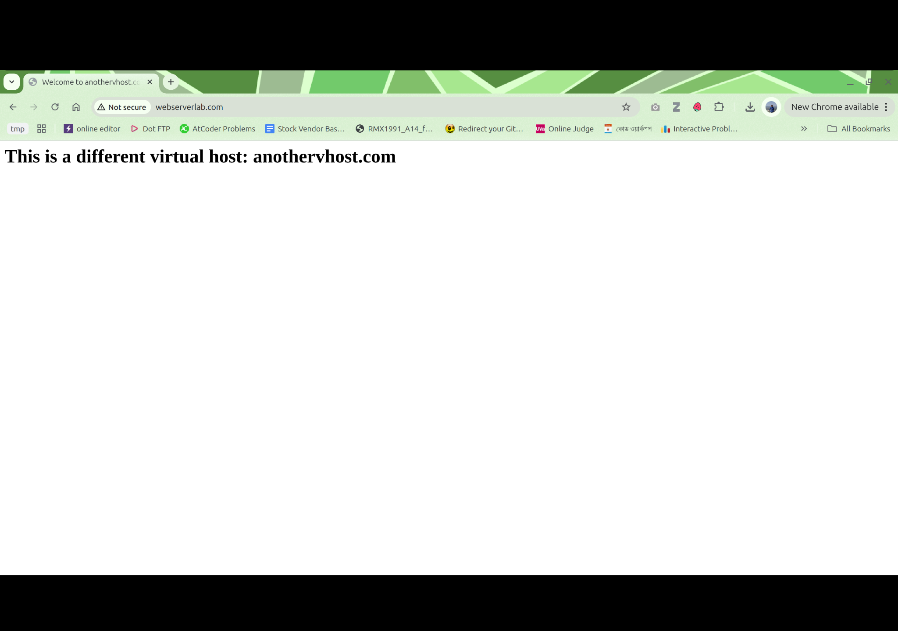

## **🔹 Checkpoint-4: Creating a Second Virtual Host (anothervhost.com)**

### **Step 4.1 – Create Directory Structure**

sudo mkdir -p /var/www/anothervhost.com/html

sudo chown -R $USER:$USER /var/www/anothervhost.com/html

sudo chmod -R 755 /var/www/anothervhost.com

### **Step 4.2 – Create HTML Content**

nano /var/www/anothervhost.com/html/index.html

<html>

<head><title>Welcome to AnotherVHost!</title></head>

<body><h1>This is another virtual host site.</h1></body>

</html>

### **Step 4.3 – Create Configuration File**

sudo nano /etc/apache2/sites-available/anothervhost.com.conf

<VirtualHost *:80>

ServerAdmin admin@anothervhost.com

ServerName anothervhost.com

ServerAlias www.anothervhost.com

DocumentRoot /var/www/anothervhost.com/html

ErrorLog ${APACHE_LOG_DIR}/another_error.log

CustomLog ${APACHE_LOG_DIR}/another_access.log combined

</VirtualHost>

### **Step 4.4 – Enable Site and Restart Apache**

sudo a2ensite anothervhost.com.conf

sudo apache2ctl configtest

sudo systemctl restart apache2

### **Step 4.5 – Update Hosts File**

127.0.0.1 localhost webserverlab.com example.com anothervhost.com

### **Step 4.6 – Test Both Sites**

Visit:

http://example.com

http://anothervhost.com

Each should load its own distinct page.

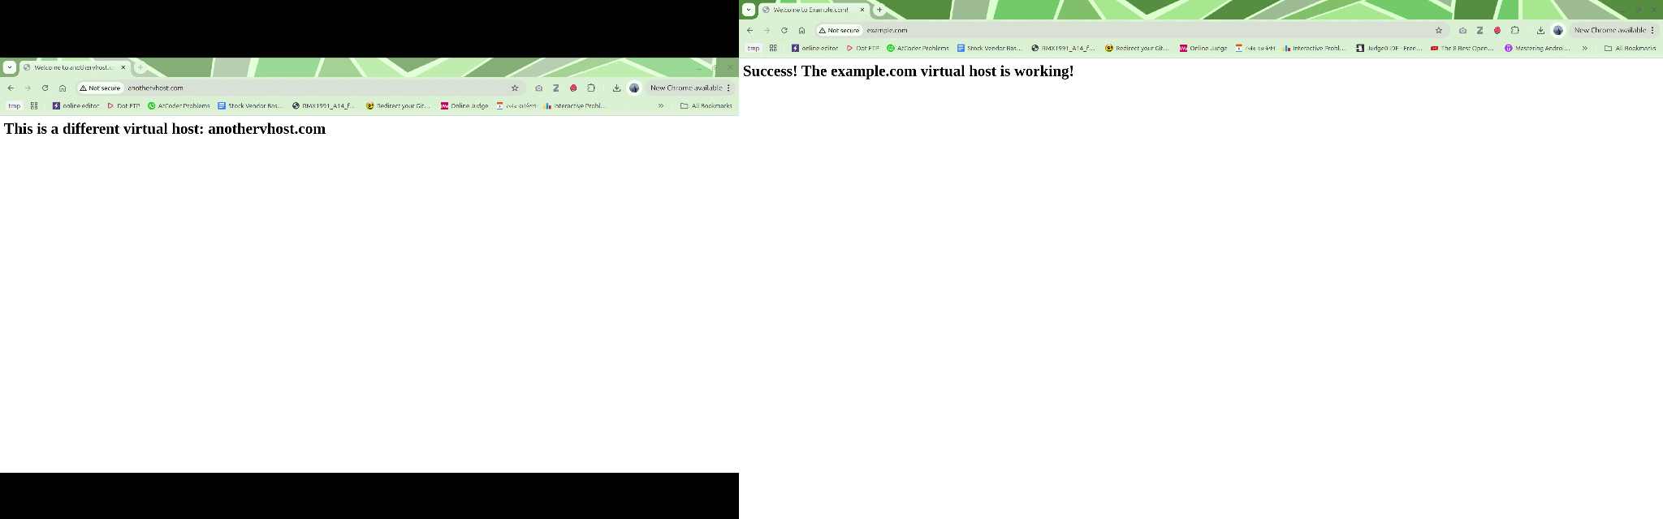

Here’s the continuation of your **Web Lab Report** — the section for **Checkpoint-5 (Dynamic Websites)** written in the same professional, easy-to-read format with clear screenshot indicators.

## **🔹 Checkpoint-5: Hosting Two Dynamic JavaScript-Based Websites**

### **Step 5.1 – Verify Existing Virtual Hosts**

Ensure both virtual hosts are already configured and working:

sudo a2ensite example.com.conf

sudo a2ensite anothervhost.com.conf

sudo systemctl restart apache2

Verify in /etc/hosts:

127.0.0.1 localhost webserverlab.com example.com anothervhost.com

### **Step 5.2 – Dynamic Website 1: example.com (Simple Calculator)**

#### **a. Create/Replace HTML file**

nano /var/www/example.com/html/index.html

Paste the following:

<!DOCTYPE html>

<html>

<head>

<meta charset="utf-8" />

<title>Example.com - Simple Calculator</title>

</head>

<body>

<h1>Simple Addition Calculator</h1>

<form id="calcForm">

<label>Number 1:

<input type="number" id="num1" required />

</label><br /><br />

<label>Number 2:

<input type="number" id="num2" required />

</label><br /><br />

<button type="submit">Add</button>

</form>

<h2 id="result"></h2>

<script>

const form = document.getElementById("calcForm");

const result = document.getElementById("result");

form.addEventListener("submit", function (e) {

e.preventDefault();

const a = parseFloat(document.getElementById("num1").value);

const b = parseFloat(document.getElementById("num2").value);

if (isNaN(a) || isNaN(b)) {

result.textContent = "Please enter valid numbers.";

} else {

result.textContent = "Result: " + (a + b);

}

});

</script>

</body>

</html>

#### **b. Test in Browser**

Visit:

http://example.com

Enter two numbers and press **Add**.  
 The result should appear dynamically.

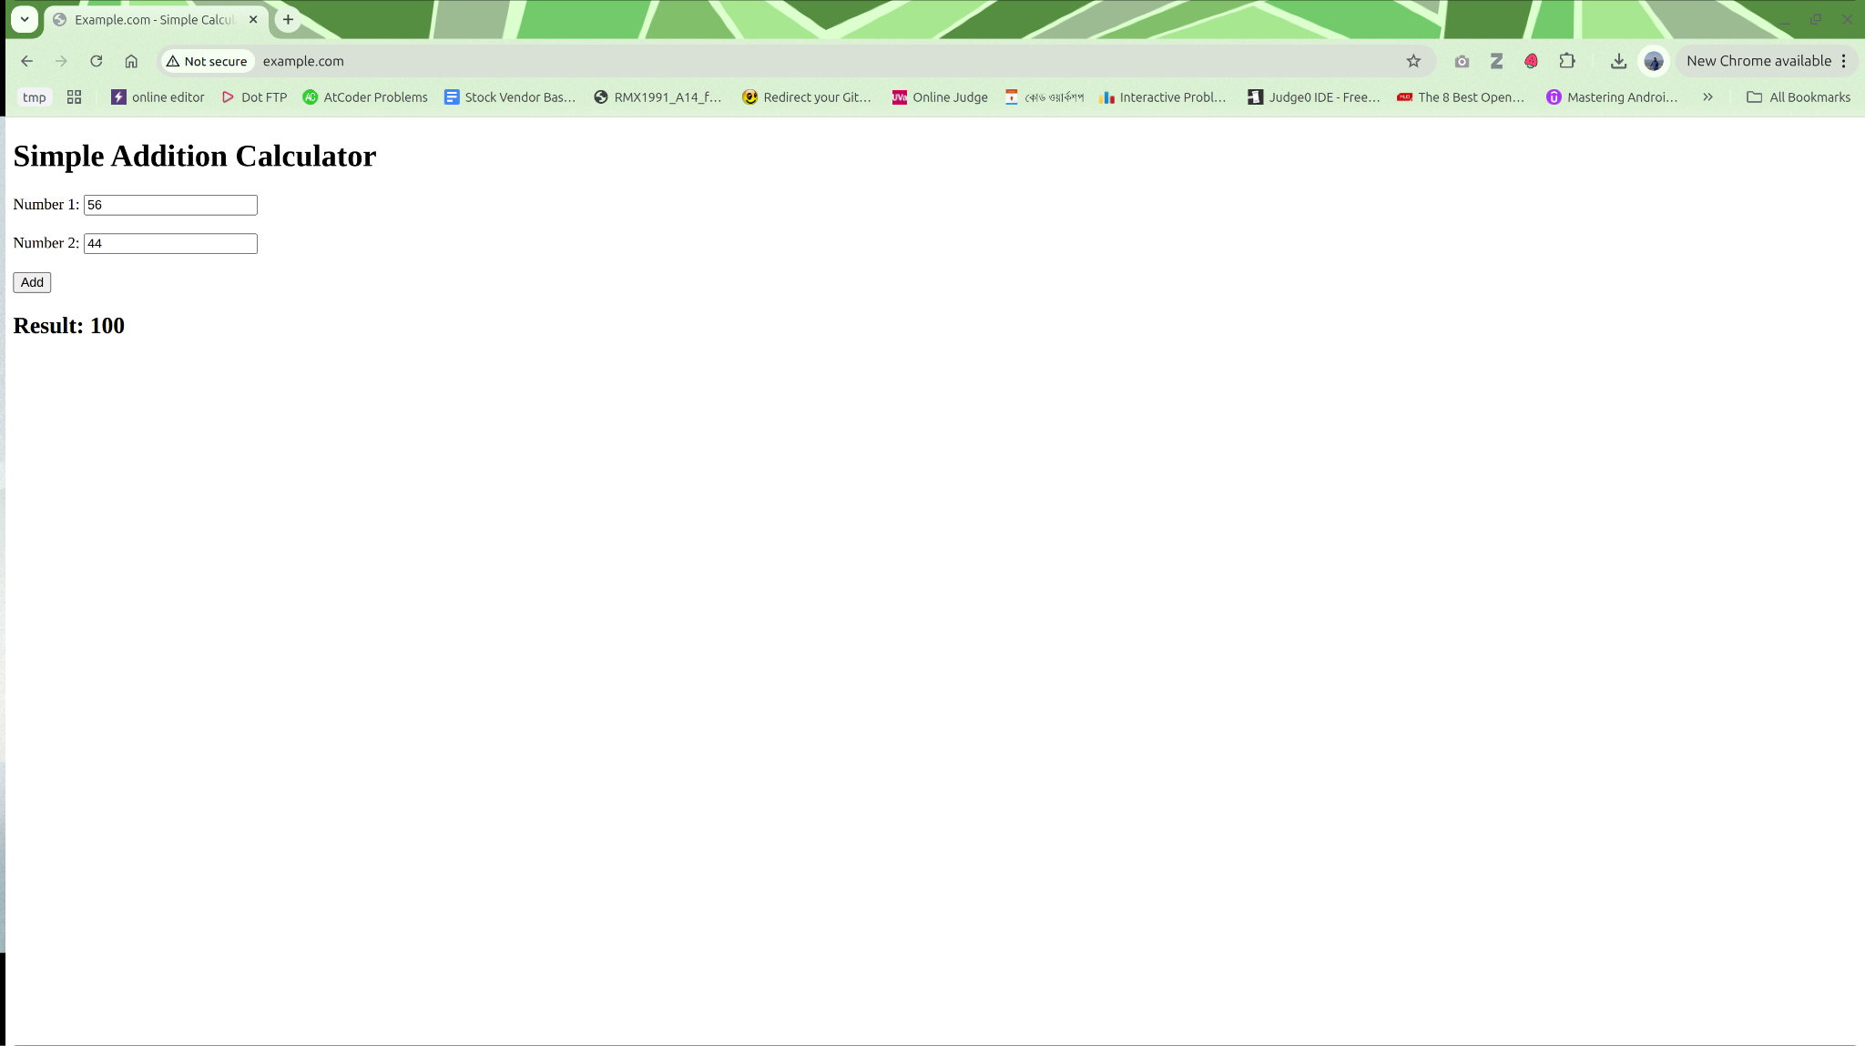

### **Step 5.3 – Dynamic Website 2: anothervhost.com (Grade Calculator)**

#### **a. Create/Replace HTML file**

nano /var/www/anothervhost.com/html/index.html

Paste:

<!DOCTYPE html>

<html>

<head>

<meta charset="utf-8" />

<title>Anothervhost.com - Grade Calculator</title>

</head>

<body>

<h1>Grade Percentage Calculator</h1>

<form id="gradeForm">

<label>Quiz (out of 20): <input type="number" id="quiz" required /></label><br /><br />

<label>Midterm (out of 30): <input type="number" id="midterm" required /></label><br /><br />

<label>Final (out of 50): <input type="number" id="final" required /></label><br /><br />

<button type="submit">Calculate Total & Grade</button>

</form>

<h2 id="gradeResult"></h2>

<script>

const form = document.getElementById("gradeForm");

const output = document.getElementById("gradeResult");

form.addEventListener("submit", function (e) {

e.preventDefault();

const quiz = parseFloat(document.getElementById("quiz").value);

const mid = parseFloat(document.getElementById("midterm").value);

const fin = parseFloat(document.getElementById("final").value);

if (isNaN(quiz) || isNaN(mid) || isNaN(fin)) {

output.textContent = "Please enter all scores.";

return;

}

const total = quiz + mid + fin;

let grade;

if (total >= 80) grade = "A+";

else if (total >= 70) grade = "A";

else if (total >= 60) grade = "B";

else if (total >= 50) grade = "C";

else grade = "F";

output.textContent = "Total: " + total + "/100, Grade: " + grade;

});

</script>

</body>

</html>

#### **b. Test in Browser**

Visit:

http://anothervhost.com

Input quiz, midterm, and final marks → click **Calculate** → total and grade appear instantly.

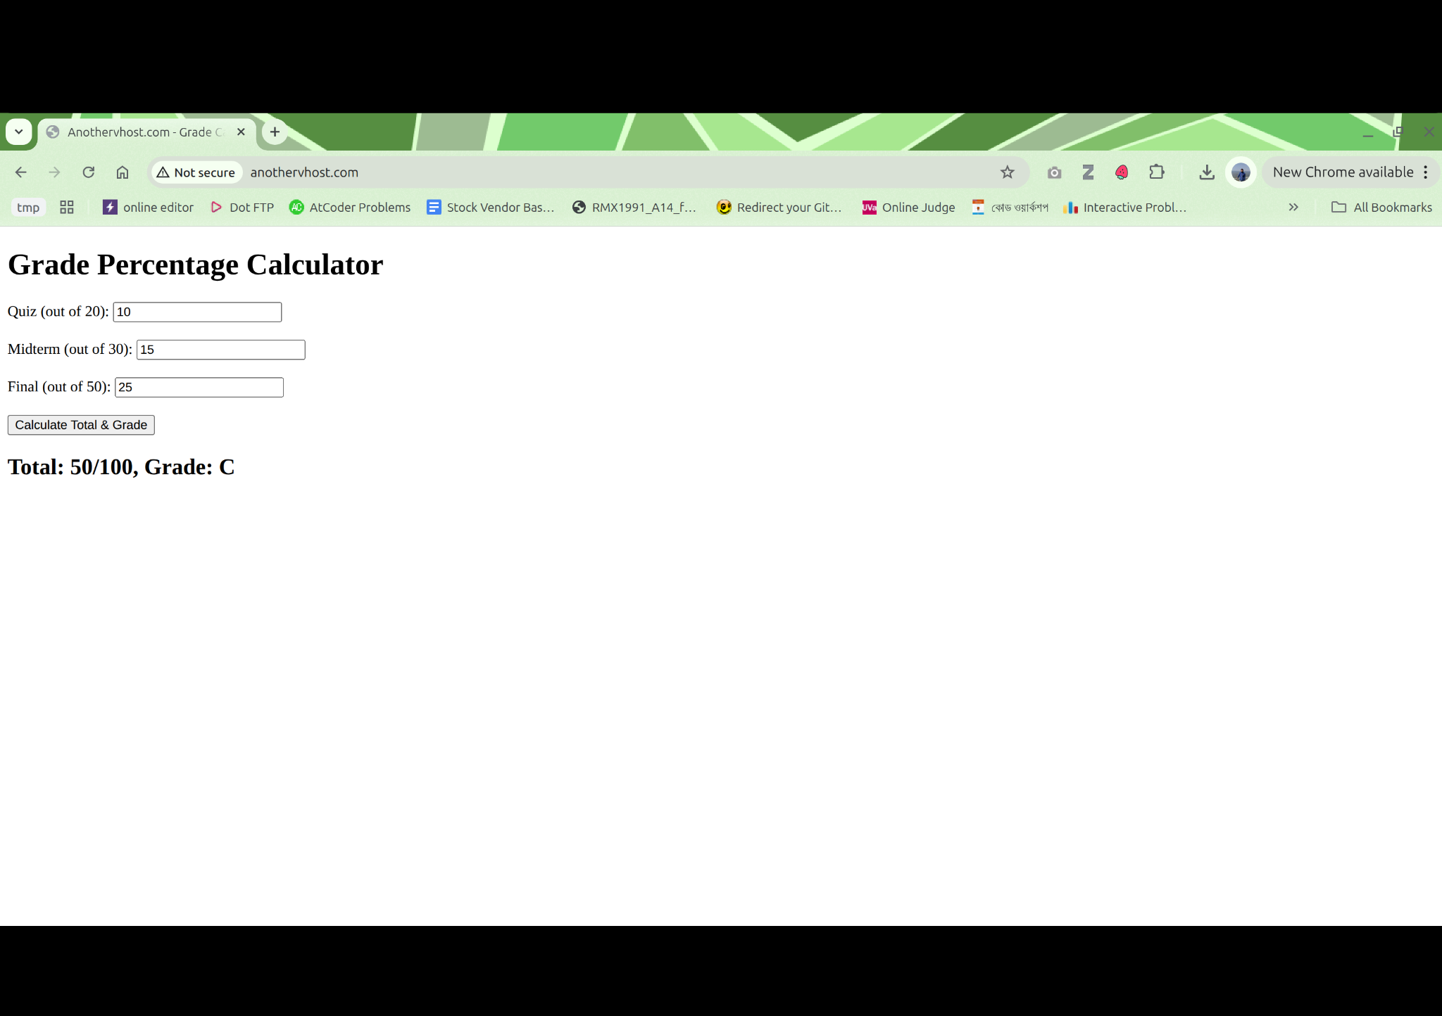

### **Step 5.4 – Validation**

Both sites work independently and dynamically:

|  |  |  |
| --- | --- | --- |
| **Virtual Host** | **Functionality** | **Dynamic Feature** |
| example.com | Addition Calculator | JavaScript form + instant result |
| anothervhost.com | Grade Calculator | JavaScript form + instant grade output |

## **🔹 Observations**

* Apache successfully serves multiple **dynamic** front-end websites.
* No server-side language was used; all logic handled via **client-side JavaScript**.
* Each virtual host uses its own document root and configuration file.
* Demonstrates the concept of **hosting multiple applications/domains** on a single local machine.